**INTI International College Penang School of Engineering and Technology**

**3+0 Bachelor of Science (Hons) in Computer Science, in collaboration with Coventry University, UK**

**3+0 Bachelor of Science (Hons) in Computing, in collaboration with Coventry University, UK**

**Coursework cover sheet**

**Section A - To be completed by the student**

|  |  |
| --- | --- |
| Full Name: Sulaiman Sidek Bin Azman Shah | |
| CU Student ID Number: P21013694 | |
| Semester: 3 | |
| Session:  **April 2022** | |
| Lecturer:  **Nadhrah Abdul Hadi (nadhrah.abdulhadi@newinti.edu.my)** | |
| Module Code and Title:  **4067CEM Software Design** | |
| Assignment No. / Title:  **Continuous Assessment** | % of Module Mark:  **50** |
| Hand out Date:  **22nd April 2022** | Due Date:  **Task 1: 13 May 2022, by 11.59pm**  **Task 2: 1 July 2022, by 11.59pm**  **Task 3: 17 June 2022, by 11.59pm.**  **Task 4: 17 June 2022, by 11.59pm.**  **Task 5: 17 June 2022, by 11.59pm.** |
| Penalties: No late work will be accepted. If you are unable to submit coursework on time due to extenuating circumstances, you may be eligible for an extension. Please consult the lecturer. | |
| Declaration: I/we the undersigned confirm that I/we have read and agree to abide by the University regulations on plagiarism and cheating and Faculty coursework policies and procedures. I/we confirm that this piece of work is my/our own. I/we consent to appropriate storage of our work for plagiarism checking.  Signature(s): ________________________ | |

**Section B - To be completed by the module leader**

|  |  |  |
| --- | --- | --- |
| Intended learning outcomes assessed by this work:  1. Understand and apply appropriate concepts, tools and techniques to each stage of the software development  2. Understand and apply design patterns to software components in developing new software  3. Demonstrate an understanding of project planning and working to agreed deadlines, along with professional, interpersonal skills and effective communication required for software production  5. Demonstrate an awareness of, and ability to apply, social, professional, legal and ethical standards as documented in relevant laws and professional codes of conduct such as that of the Malaysian National Computer Confederation. | | |
| Marking scheme | Max | Mark |
| 1. User Story Mapping 2. Setting up a GitHub Repository 3. Creating a Class diagram and design pattern selection 4. Creating a Prototype User Interface and Usability Testing 5. Discuss the ethical issue related to the software | 20  10  30  20  20 |  |
| Total | 100 |  |

**Class Diagram**

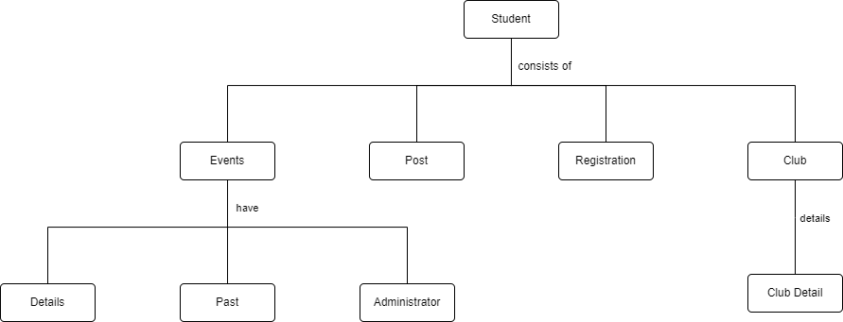

In this event website, user also known as student are able to manage their accounts in login, change or delete personal details.

Users are able to enter the website and

* visit homepage
* visit upcoming or past event page
* visit post page
* visit club page

From the homepage, users can either click on News and Events, Post, Club or log out in the page. When the users click on News and Events, on the upcoming event page they are able to select the event that they want to check it out or register to join it. In the registration, the users will have to enter their personal details. After that, it will display that the user’s registration has been approved or not. For the past event page, the users can see all the history event that have take place in the college.

Besides that, in the post page they will see all the comments from others student regrading of all the past event. The users are also able to give their personal feedback in the page.

They users can check their own club that they enter and all the others club that are still available. If they want to join, the users can use the same steps that been used in the event page to register

**UML Diagram**

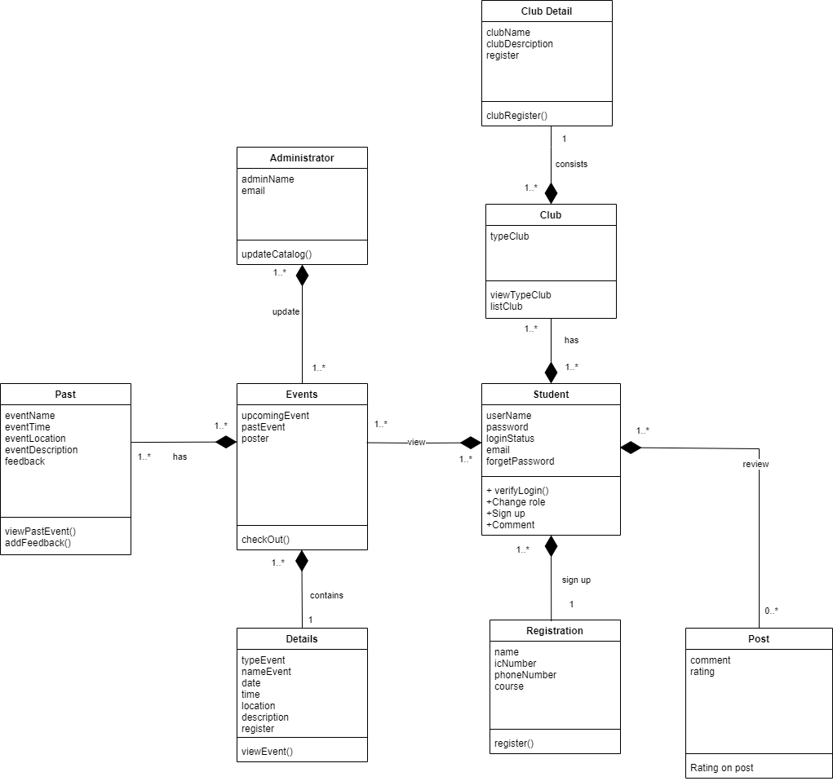

The design pattern that I choose for this system Factory Method. Even though the design pattern it is a bit more complicated than the others but it is able to create a design that is more customizable. Compare the others design pattern which needed new classes while for Factory Method only need a new operation.

Factory Method are often use as a standard way to built objects. The various scenarios can be proven the valuable by using this design pattern. From the alternative approach for subclass management where software the concrete product is to be created are unknown and not defined in advance.

From factory design pattern authentication system also are benefited factory classes that made independent decision above the handling of the user the authentication process can be delegated.

Adding to this, factory pattern design accordingly is generally suitable for all software in which new classes are added regularly and according to plan.